Running title: Not to exceed 30 characters and spaces

Pathways to Create New Peanut (Arachis hypogaea) Products (All Bold Letters)

A.N. Author, B.S. Second, D.A. Third, and A.I. Last *

ABSTRACT
Place the abstract on the 2nd page after the title and author’s page (do a hard return page break in Word by placing cursor at end of the author list and hit ‘ctrl’ & ‘Enter’). Do include the word ‘ABSTRACT’ in bold at the top of the page. The text of the abstract should not exceed 3% of the length of the manuscript, including tables but not including the Literature Cited. It must be written as a single paragraph and must contain an objective and informative digest of the significant content of the paper, not simply a description of the contents. Representative quantitative data from the results often make the abstract more informative. Use only common names in the body of the abstract for pesticides, plants, animals, and microorganisms. Omit tables, graphs, long lists of names, references to literature, or footnotes. At the first mention of the pesticide rate, express the rate either on the acid equivalent (ae) basis or active ingredient (ai) basis. Omit trade names for all products such as pesticides, equipment, etc. in the abstract.

Key words: Cleaning, foreign material, loose shelled kernels, LSK, Zea mays L. [After the abstract, type the phrase “Key words” at the left margin. Use boldface type, followed by a colon. List words, word pairs, or phrases (usually not more than five words) not included in the title or nomenclature that further describe the content of the manuscript. List only specific words or phrases that will be useful in indexes and in computerized literature searches. Capitalize only the first letter of the first word of this list, except for proper names. Alphabetize the list and place a comma after each word or phrase and a period after the last word.]

Introduction
Introduction, Materials and Methods, Results and Discussion, and Acknowledgments.
These sections follow the Key words section in that order. Each first-level section head is centered on the second line below the preceding section. Text begins one line below each heading. Begin the introduction on same page. There is a heading for the Introduction section as shown above.
The preferred format of the document submitted for review and consideration for publication in Peanut Science is a Microsoft Word document (.docx). As an alternative, the submitter may submit the document for review in a pdf format.

Materials and Methods
Second Level Heading Boldface.
Third-Level Heads Italic.
Fourth-level heads italic.
Type second-level heads flush left and boldface, with the first letter of each word capitalized, and end with a period. Third-level heads are flush left and italic, with the first letter of each word capitalized, and end with a period. Fourth-level heads are paragraph indented, italicized, with only the first letter capitalized, and end with a period. The text following second-, third-, and fourth-level heads should immediately follow the head on the same line. Each paragraph of the body text should be first line indented by 0.25 in. and left-justified. Do not use the tab key for the first line indention, use the paragraph formatting. Line spacing shall be double-spaced and no spacing before or after paragraphs (Figure 1).
Figure 1. Paragraph and line spacing for text in the body of the manuscript for submission to Peanut Science.
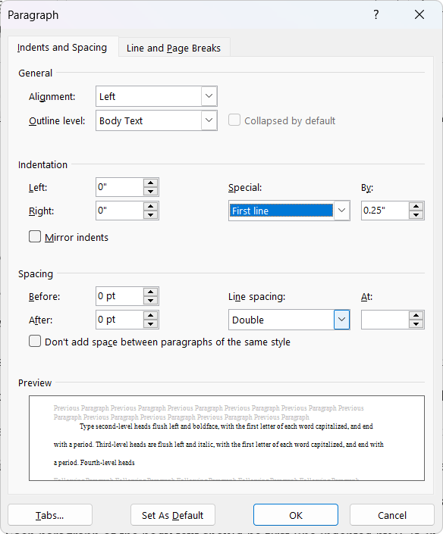
The author (year) format should be used when citing references throughout the manuscript. If the cited reference is authored by two authors or less, use the surnames of both authors (Chase and Appleby, 1979). When the cited reference has more than two authors, then the reference shall be cited using the surname of the first author followed by et al. followed by the publication year (Smith et al., 2024). When the citation is referenced parenthetically, the author designation and year should be separated by a comma. If multiple citations are referenced parenthetically, citations should be separated by semi-colons (Boote, 1982; Doll and Piedrahita, 1982). If you use Microsoft Word’s Reference Manager or EndNote®, convert the bibliography and citations to a static list rather than using the active links in the submitted manuscript. Peanut Science currently follows the APA 7th edition style guide for citing references (Purdue University, 2024)
In the Materials and Methods section, the sources of the material should be shown in parentheses following the first mention. Provide a brief description of the item, model number (if applicable), and the source. The company’s address (full mailing address or just city and state/country) may also be included although it is not required. Following is an example: “During a single year, large plots were treated with glyphosate (Roundup WeatherMax®, 540 g ai L⁻¹, Monsanto Company, 800N. Lindbergh, Blvd St. Louis MO, 63167).”
When specifying the latitude and longitude of an experimental site, weather station, or other location the decimal format (31.75982, -84.43489) is preferred, but the degree, minutes, seconds (31° 45’ 35.35’’ N, 84° 26’ 5.60” W) format is acceptable. If directional indicators such as N, S, E, and W are used (31° 45’ 35.35’’ N, 84° 26’ 5.60” W), then the minus sign is not used. If the directional indicators are not used, then the minus sign is used to indicate South latitude (S) and West longitude (W).
Submissions including five or more products (pesticides, equipment, solvents, disposable materials used for lab analysis) should be listed in a Table providing the following details: product common and trade names, formulation (if necessary), name of respective manufacturer, and manufacturer city, state, and website (no mailing address or zip code). Excessively long product lists are lists in the text are also discouraged. Use one sentence in the Materials and Methods and/or other appropriate locations within the manuscript to refer readers to the Table. Likewise, when it is necessary to describe more than one experiment with five or more products, the information can be listed in the same Table or in an additional Table. Table formatting will be discussed in the next section.

Results and Discussion
The use of separate Results and Discussion sections and a separate concluding section are generally discouraged, but authors may wish to conclude the Results and Discussion section with an untitled summary.
Tables and figures are usually an integral part of the Results and Discussion of a manuscript. For the submission and review of the manuscript, both figures and tables can be placed in the document either as soon as possible after the first mention of the table or figure or they may all be included at the end of the document. All tables and figures should be sized and arranged such that they will fit on the page in a portrait orientation. If a manuscript is accepted for publication then the author will be expected to provide a copyedited version of the manuscript, with tables and figures ready for publication. Formatting for both are described below.
Tables
Submission and Review
DO NOT USE TABS OR OTHER METHODS TO CREATE TABLES. Use the table function in Word. Tables should not be more than 120 character-spaces wide (7 in, 178 mm). All pages should be portrait orientation. Do not use landscape orientation to accommodate a wider table. If the table is too wide for portrait orientation, break the table into two tables. First reference to tables included primarily to present results should be in the Results and Discussion section. All text within each table should be in lower case letters except for the first word of a phrase or sentence, proper nouns which should have initial capitals, and Bayer codes. Column headings should relate to data or information in the body of the table, not just to other information in column headings.
Each table with its caption should be fully self-explanatory. Avoid the use of exponents in column headings. When reporting data for a number of years or locations, group the data in adjacent columns under each factor measured. This facilitates comparison for repeatability of responses. The unit of measurement for a column of figures should be abbreviated and placed at the top of the column below the solid horizontal line. Do not place the unit of measurement in parentheses. If horizontal lines in a table need to span more than one cell, it is advisable to merge the cells to prevent line breaks from being introduced during typesetting. Footnotes to tables should be designated with superscript lowercase letters at the highest appropriate level within the table, except probability values, which should use asterisks. Study the form of a table in a recent copy of Peanut Science. Place letters in a different column than the numbers used to indicate significant differences. For reviewing, and revisions, the caption for each table should be included in the first row of the table with all cells in the first row merged into a single cell across the width of the table. This ensures that the caption and table do not get separated during the review and subsequent revisions.
Footnotes for the table should all be placed in a single cell merged last row of the table. All footnotes should be placed in the single row. Do not use a separate merged row for each footnote. The table should be left justified with no text wrapping. See Table 1 below as an example.

Table 1. Seasonal weather summary at the Southwest Georgia Research and Education Center located in Plains, Sumter County, GA (32.046760, -84.371020) for the period ending 07 Mar 2025. (place the caption in the first row of the table)ª
Variable | Last 7 days | Last 30 days | Last 60 days | Last 180 days | Last year
Total precipitation (mm) | 24 | 93 | 147 | 577 | 1429
Number of rain days | 1 | 8 | 22 | 51 | 112
T_{max}, ^{b} C | 20.0 | 19.4 | 16.1 | 20.6 | 25.0
T_{min}, ^{c} C | 5.0 | 6.7 | 3.3 | 8.3 | 13.3
T_{avg}, ^{d} C | 12.2 | 12.8 | 9.4 | 13.9 | 18.9
T_{soil}, ^{e} C | 12.8 | 13.3 | 10.6 | 15.6 | 21.1
ª Place the footnotes in the last row of the table. Footnotes in the table use letters, not symbols or numbers.)
^{b} T_{max} is the mean daily maximum air temperature for the specified time period.
^{c} T_{min} is the mean daily minimum air temperature for the specified time period.
^{d} T_{avg} is the mean daily average of Tmax and Tmin for the specified time period.
^{e} T_{soil} is the mean daily average soil temperature measured at a depth of 10 cm.

Table 2 is an example of a table that has multiple columns that have the same units and how those units should be displayed within the table.
Table 2. Peanut stand and yield as influenced by row pattern.
 | Stand |  |  |  |  |  | Yield
Row pattern on 92 cm | Ty Ty |  |  | Plains |  |  | Ty Ty |  |  | Plains
 | ____________ #/m ____________ |  |  |  |  |  | __________________ kg/ha __________________
Single row | 8.5 | aª |  | 5.5 | a |  | 4510 | c |  | 5100 | a
Double row | 8.3 | a |  | 5.5 | a |  | 5010 | bc |  | 5200 | a
Three row | 8.9 | a |  | 5.5 | a |  | 5420 | bc |  | 5000 | a
Four row | 9.5 | a |  | 6.3 | a |  | 5860 | ab |  | 5140 | a
Five row | 9.3 | a |  | 6.8 | a |  | 6000 | a |  | 4210 | b
ªMeans within a column followed by the same letter are not significantly different from each other according Fisher's protected LSD test at P ≤ 0.05.

Accepted and Copyedited
If/when the manuscript is accepted for publication, the caption will be removed from the table and placed above the table by the authors during the copyediting process and moved to the end of the manuscript for tagging and typesetting (Table 3) immediately following the Literature Cited section. Other modifications to formatting of the table will occur during typesetting to facilitate presentation on the website in an XML format and for download in a PDF format. Tables are converted to a PNG graphic format for use in the XML file.
Figures
In general, all figures should be high quality graphics with a minimum resolution of 300 dpi and in either PNG or JPG graphic format. PNG is the preferred graphic format. Lettering that is in the graphic, such as axis labels, titles, and legends should be fully legible if the graphic is reduced to a 3.5-in (89-mm) width to fit in a single column of print. Most graphics will span the full width of a printed page (7 in, 178 mm). When multiple graphs are used in a single figure, all graphs should be combined with their labels (A, B, C, etc.) into a single graphic image before inserting into the word document as a figure.
Submission and Review
For submission and review, figures should be placed in the body of the text as soon as possible following their first mention. When inserting the graphic, it shall be inserted with the Text Wrapping Style set as “In line with text.” Use the “Insert Caption” tool to label the image, with the caption to appear “above the image.” The figure caption should be sentence case, bold typeface in the same font, size, and color as the body of the manuscript.
Figure 2. A farmers' stock peanut receiving station in Queensland, Australia.
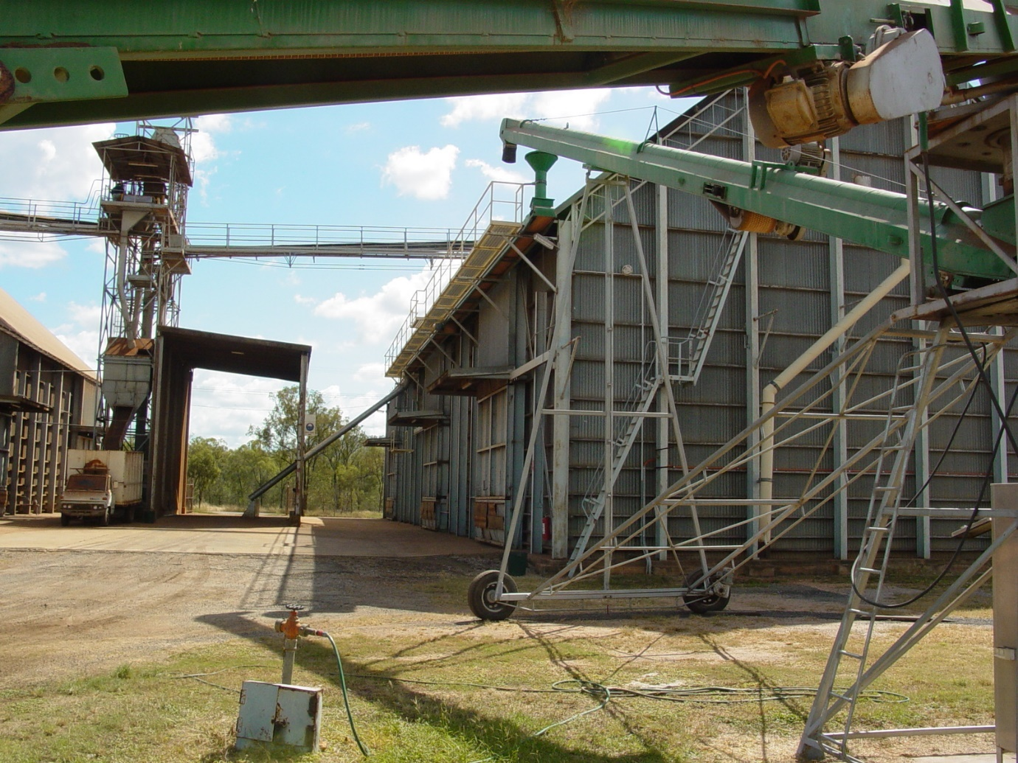
Accepted and Copyedited
Upon acceptance figures, like the tables, will be removed from the body of the text and moved to the end of manuscript in the order they are mentioned along with their captions. Authors will be asked to provide individual graphic files for each figure used in the manuscript. Each file should be a 300 dpi PNG file, using the manuscript number and Figure identification as the file name. For example, Figure 1 in the accepted manuscript, PS1641 will be named PS1641-Fig 1.PNG and uploaded with the final manuscript. Upload each figure as a separate file.
Authors are encouraged to submit photos that may be used as a banner for the article when viewed online to make the manuscript more compelling. The authors may also submit a photo of their research that may be used as a cover photo for the issue.

Acknowledgments
Under Acknowledgments please specify contributors to the article other than the authors accredited. Please also include specifications of the source of funding for the study and any potential conflict of interests, if appropriate.

Literature Cited
[Entries in the bibliography should be listed using the APA Style Guide (Purdue University, 2024). A period should appear at the end of each reference including doi or url.]

Boote, K.J. 1982. Growth stages of peanut (Arachis hypogaea L.). Peanut Sci. 9:35-40.
Branch, W.D. 2003. Registration of ‘Georgia-02C’ peanut. Crop Sci. 43:1883-1884.
Chase, R.L., and A.P. Appleby. 1979. Effects of humidity and moisture stress on glyphosate control of Cyperus rotundus L. Weed Res. 19:241-246.
Doll, J.D., and W. Piedrahita. 1982. Effect of glyphosate on the sprouting of Cyperus rotundus L. tubers. Weed Res. 22:123-128.
Elmasry, R., and S. Rehm 1977. Effects of growth-regulators and herbicides on purple nutsedge (Cyperus rotundus L). Zeitschrift Fur Acker Und Pflanzenbau-J. Agron. Crop Sci. 144:259-267.
Gorbet, D.W. 2007. Registration of 'AP-3' Peanut. J. Plant Registrations. 2:126-127.
Gomez, K.A., and A.A. Gomez 1984. Factorial experiments pp. 89-91. In Statistical procedures for agricultural research. 2nd ed. John Wiley & Sons, New York.
Purdue University, College of Liberal Arts. (2024). APA formatting and style guide (7th edition). APA Formatting and Style Guide (7th Edition) - Purdue OWL® - Purdue University. https://owl.purdue.edu/owl/research_and_citation/apa_style/apa_formatting_and_style_guide/index.html.
Smith, A., S. Bag, A. Rabinowitz, R. Kemerait, R. Srinivasan, M. Abney, W. Branch, and A. Culbreath. 2024. Comparison of field performance of Georgia-16HO and Florunner cultivars in the presence of Tomato Spotted Wilt. Peanut Sci. 51(1):1-7. doi: 10.3146/0095-3679-51-PS23-5.

First, third, and fourth authors: Graduate Student, Assistant Professor, and Professor, Crop Sciences Dept., Any University, Someberg, GA 12345; Second author: Professor, Agronomy Department, Happy University, Ghosttown, IL 76543. *Corresponding author’s E-mail: correspondingauthor@mymail.net

